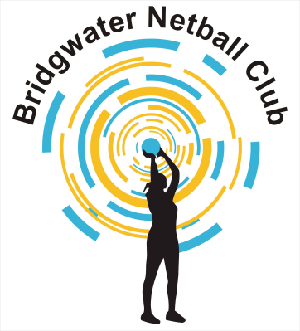

**BRIDGWATER NETBALL CLUB**

**UMPIRE**

**Umpires shall:-**

1. Be appropriately qualified, with comprehensive knowledge of the rules, using the correct terminology when officiating.
2. Ensure knowledge is kept up-to-date by attending training where appropriate.
3. Have good knowledge of all match protocols.
4. Dress appropriately when officiating and be in possession of the correct aids.
5. Ensure the court is safe for playing.
6. Ensure the players abide by the rules prior to, and during, the game.
7. Control the game in an equitable and safe manner, ensuring decisions are consistent and fair.
8. Establish a rapport with players so that everyone enjoys the game.
9. Earn the respect of the players.
10. Adhere to the England Netball Duty of Care Guidelines.